1. HRM home page should appear as per the below screen shot

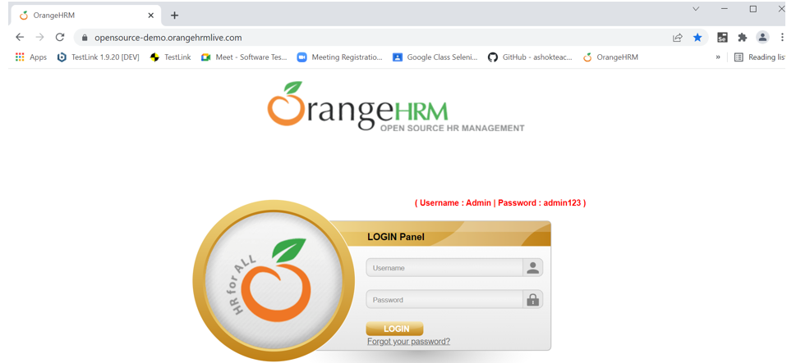

1. If user enters wrong password with correct user id system should display below error message

**Invalid credentials**

1. If user enters wrong password more than 3 times account should be locked for 24 hours and system should display error message stating “Your account is locked for 24 hours please try after 24 hours”
2. System should display error message “You already made 2 wrong passwords and on 3rd attempt your account will be locked for 24 hours”
3. Once user enters valid user id and password system should allow to login and below screen should appear after login. System should display Dashboard screen

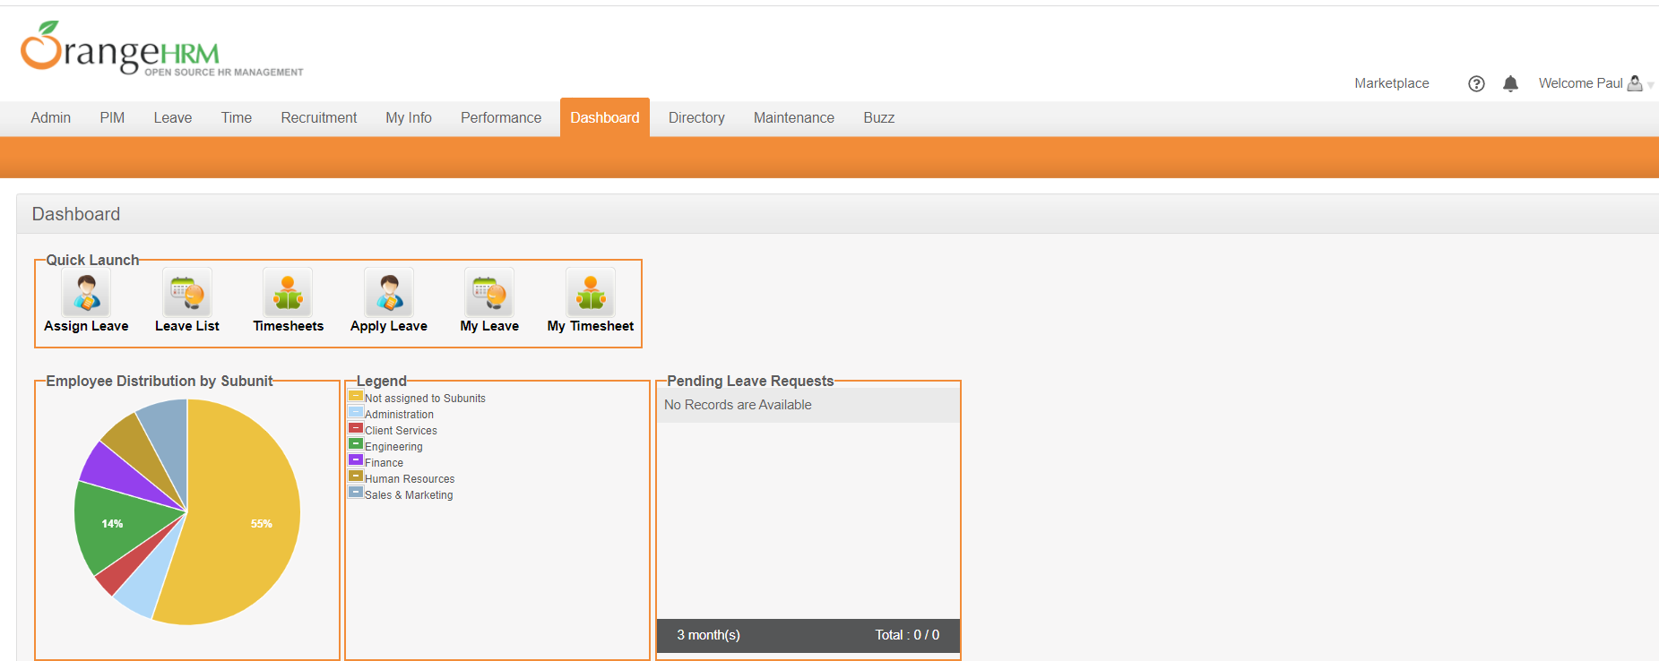

1. Admin: This tab should have below futures
2. User Management
3. Job
4. Organization
5. Qualifications
6. Nationalities
7. Corporate Banking
8. Configuration

6.1 User Management: In this we have futures as per below

1. Search for existing users: System should allow to search users with below criteria
   1. User name: In this filed we need to enter any existing employee name and click on search button. It should display employee details as per the given employee name with below results: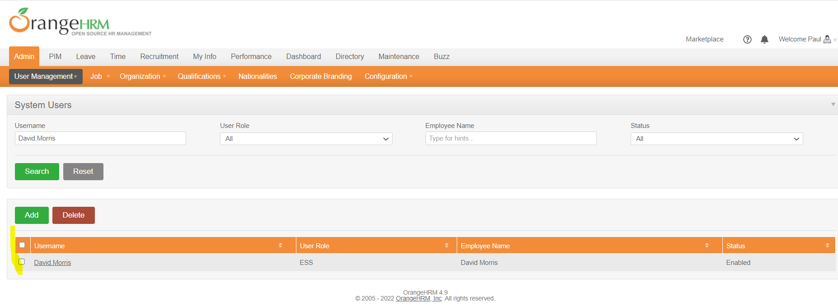
   2. User Role: It is a drop-down and it should contain two roles “Admin” and “ESS”. Based on user role selected it should display search results with below information

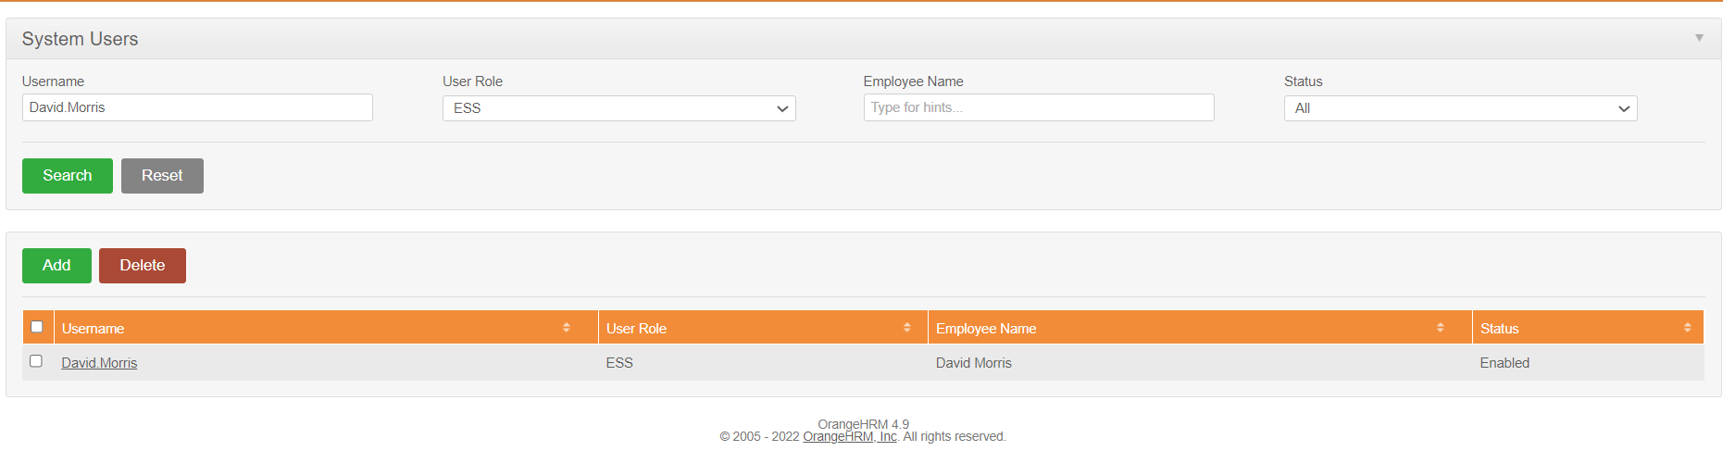

If no user is available for selected role then system should display as per below

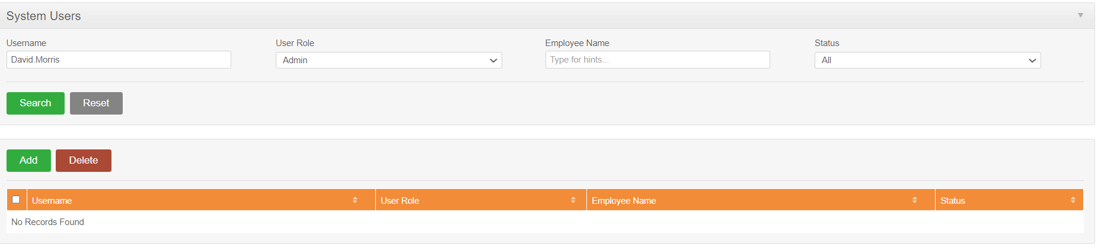

* 1. Employee Name: It is a text field and should allow to enter employee name and click on Search button. If employee exist it should display employee information if not it should display message as “No Results Found” as per given screen shots above
  2. Status: It is a drop-down and should contain values “All”, “Enabled” & “Disabled”. Search results should be displayed based on Status selected. If no records found then it should display “No Results Found”.

1. Add User: This future should allow the user to add new user. Once user clicks on Add User it should display below screen

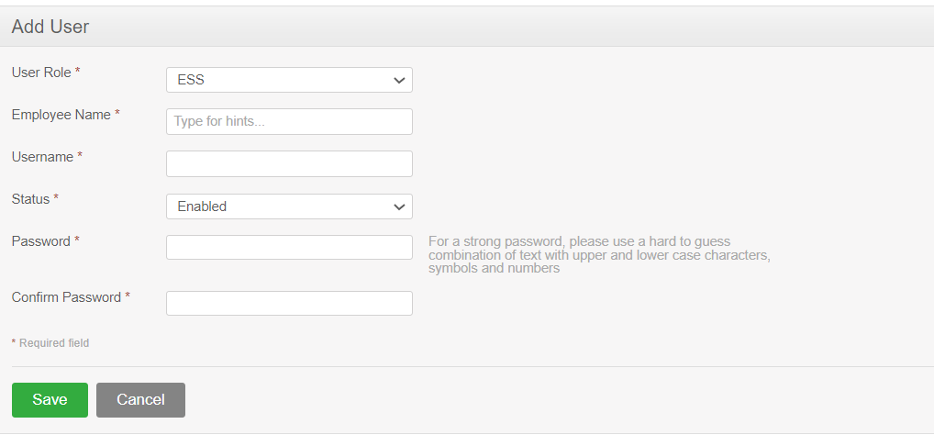

* 1. Once user enters all the required details and clicks on Save it should display message “Successfully saved”
  2. System should not allow to create duplicate user based on field “Username”. If user enters duplicate user name system should display message stating “User already exist”

1. Delete user: This future is allowed to delete user. To delete user we need to search the user and select the user to delete. Once you select user to delete and click on Delete button it should delete user and display message

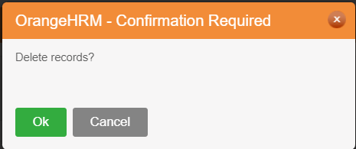

Once user clicks on delete “OK” button system should display message stating “Successfully deleted”

Field Level Requirements:

1. Employee Name:
   1. It is a required field and if user is not entering the data system should display error message stating “Employee name is required”
   2. This field should take minimum of 5 letters and maximum of 100 letters
   3. This filed should take only letters
   4. If user enter less than 5 letters system should display an error message stating “Employee name should be minimum of 5 letters and maximum of 100 only” should be displayed.
   5. If user enters other than letters system should display message stating “Employee name must be letters only”
2. User Name:
   1. It is a required field. If user does not enter any value then system should display an error message stating “User Name is required field.
   2. It should take minimum of 5 letters and maximum of 20 letters.
   3. If user enters less than minimum and more than maximum then system should display an error message stating “User Name filed should be minimum of 5 letters and maximum of 20 letters”
   4. It should aplpha numric data
   5. If user enters other than aplphanumric data system should display error message stating “User Name” field takes only alpha numeric data”